**CHAPTER 1**

**INTRODUCTION**

**1.1 Introduction to Employee Onboarding System**

Employee onboarding is a critical process for any organization, laying the foundation for a new hire’s success, engagement, and long-term retention. However, in many companies, onboarding remains a manual, time-consuming, and fragmented process—leading to inefficiencies, misplaced documentation, delayed integration, and inconsistent experiences for new employees. These challenges can hinder productivity, reduce employee satisfaction, and impact overall organizational effectiveness.

To address these issues, this project introduces a digital Employee Onboarding System that leverages modern web technologies to streamline and automate the onboarding journey. Designed for HR teams and new hires, the system offers a secure login portal, where users can access personalized dashboards. New employees can upload essential documents such as ID proofs, educational certificates, and work experience records, which are securely stored and made available for HR verification through an integrated profile authentication module.

Beyond document management and verification, the system creates a centralized onboarding experience that ensures every new hire follows a consistent, efficient, and paperless process. With features like progress tracking, status notifications, and downloadable reports, the platform enhances transparency and accountability. This solution bridges the gap between traditional onboarding practices and modern HR demands, fostering a smooth, organized, and productive entry into the workplace.

**1.2 Motivation**

The core rationale behind developing this Employee Onboarding System lies in the need to modernize and streamline the traditionally manual, error-prone, and fragmented onboarding processes that many organizations still follow. New hires often face disorganized induction experiences involving scattered documentation, unclear processes, and delays in verification, all of which can hinder their early engagement and productivity. From an HR perspective, the lack of a centralized system increases administrative workload, reduces process visibility, and raises the risk of compliance issues.

This platform is designed to address these challenges by digitizing the end-to-end onboarding workflow. By providing a secure login interface, document upload functionality, and an integrated profile verification system, it ensures a consistent and efficient experience for both HR personnel and employees. The platform simplifies the collection, review, and storage of important employee documents, while offering real-time status updates and downloadable records to keep all stakeholders informed.

Built with usability and security in mind, the system caters to both technical and non-technical users, ensuring a smooth transition into the workplace. This initiative is driven by the vision to empower HR teams with tools that improve accuracy, transparency, and operational efficiency—ultimately supporting better talent integration and a stronger organizational foundation.

**1.3 Sustainable Development Goal of the Project**

This project aligns with the United Nations Sustainable Development Goal 8 (SDG 8) – Decent Work and Economic Growth, which aims to promote sustained, inclusive, and sustainable economic growth, full and productive employment, and decent work for all. In many organizations, inefficient and inconsistent onboarding processes create unnecessary administrative burdens, delays in employee integration, and a negative first impression for new hires, ultimately affecting workforce morale and productivity.

The Employee Onboarding System developed in this project addresses these issues by digitizing and streamlining the onboarding journey. By offering features such as a secure login portal, document upload functionality, and automated profile verification, the system ensures a smoother, faster, and more transparent transition for new employees into their roles. It reduces redundant manual work for HR personnel and minimizes the risk of missing or inaccurate information, thereby supporting a more structured and accountable hiring process.

By optimizing the onboarding workflow, this platform enables organizations to integrate employees more efficiently, helping them become productive faster and reducing turnover risks. It supports a culture of professionalism, preparedness, and operational excellence, which is essential for sustainable economic growth. Additionally, by enabling remote access and centralized management, the system fosters inclusive workplace practices suitable for modern, digitally driven work environments. This initiative contributes directly to improving job quality, organizational performance, and long-term economic outcomes.

**1.4 Product Vision Statement**

**1.4.1 Audience**

* **Primary Target Group**

HR personnel and new employees who need a structured, streamlined onboarding process to ensure efficient integration into the organization.

* **Secondary Audience**

Department heads, compliance officers, and administrative staff seeking consistent documentation, verification, and onboarding workflows to support organizational efficiency.

**1.4.2 Requirements**

**Basic Needs:**

* Secure login and authentication for employees and administrators.
* Document upload and centralized profile verification system.

**Secondary Requirements:**

* Downloadable employee profile reports for compliance and records.
* Role-based dashboards with status updates and onboarding progress.
* User-friendly interface to ensure ease of use for both technical and non-technical users.

**1.4.3 Product**

* **Core Product**

A web-based onboarding system offering document upload, automated verification, and admin/user dashboards for efficient employee integration.

* **Other Features:**
  + Role-based access control (Admin/User) for task delegation and review.
  + Real-time progress tracking and onboarding completion status.
  + Secure document management and retrieval system.
  + Downloadable data for HR analytics and employee recordkeeping.

**1.4.4 Values**

**Fundamental Principles:**

* **Efficiency**

Optimizing HR processes to save time and reduce manual errors.

* **Transparency**

Ensuring a consistent onboarding experience with clear status visibility.

* **Accessibility**

Providing a digital-first platform that can be accessed remotely.

**Differentiators:**

* **Digital Workflow Automation**

Streamlining onboarding from login to verification with minimal manual intervention.

* **Centralized Document Handling**

Combining secure uploads, storage, and review in one place.

* **Economic Growth Enablement**

Supporting SDG 8 (Decent Work and Economic Growth) by improving workforce integration and organizational readiness.

**1.5 Product Goal**

The primary aim of this project is to provide organizations with a streamlined, secure, and efficient Employee Onboarding System that enhances workforce integration, reduces administrative burden, and promotes operational readiness. By digitizing the onboarding process—through secure login access, document upload, and automated profile verification—the system supports a structured and consistent entry point for new employees, enabling quicker adaptation and productivity. This directly supports Sustainable Development Goal 8: Decent Work and Economic Growth, by fostering a more organized and inclusive employment process.

Beyond basic onboarding, the platform introduces features such as downloadable employee records, status tracking dashboards, and role-based access for administrators and users. These tools ensure transparency, compliance, and accountability while simplifying HR operations. With a focus on user-friendliness, the system is built to serve both technical and non-technical users, minimizing training requirements and improving adoption across all levels of the organization.

The platform not only facilitates faster onboarding but also promotes long-term employee engagement by reducing errors and inconsistencies from day one. By ensuring that each employee is equipped with the necessary documentation and guidance at the start of their journey, the system contributes to a stronger organizational culture, improved retention, and a scalable onboarding model. Ultimately, it empowers organizations to maintain high standards of workforce management while supporting sustainable economic growth through digital innovation in human resource practices.

**1.6 Product Backlog**

**Table 1.1 User Stories Table**

|  |  |
| --- | --- |
| **S. No.** | **User Stories of Employee Onboarding System** |
| US 1 | As a user, I want a login screen so that I can secure my access. |
| US 2 | As an employee, I want a privacy notice so that I can be assured of my privacy. |
| US 3 | As an employee, I want a terms and conditions page so that I can gain agreement to terms and conditions. |
| US 4 | As an employee, I want a dashboard so that I can have one single view of core functionalities. |
| US 5 | As an employee, I want a photo upload provision so that I can upload my pic for identity. |
| US 6 | As an employee, I want a doc verification page so that I can upload my core documents. |
| US 7 | As an admin, I want a separate login so that I can secure my access. |
| US 8 | As an admin, I want an admin dashboard so that I can see total employees/applicants, pending reviews, interview schedules and selected. |
| US 9 | As an admin, I want approve/reject buttons so that I can approve or reject employees. |
| US 10 | As an employee, I want a job descriptions page so that I can see the duties related to my role. |

The product backlog of Employee Onboarding System was configured using the MS Planner Agile Board which is represented in the following Figure 1.1. The Product Backlog consists of the complete user stories of Employee Onboarding System, as given in Table 1.6.1 in the previous page.

Each user story consists of necessary parameters like MoSCoW prioritization, Functional and Non-Functional parameters, detailed acceptance criteria with linked tasks.

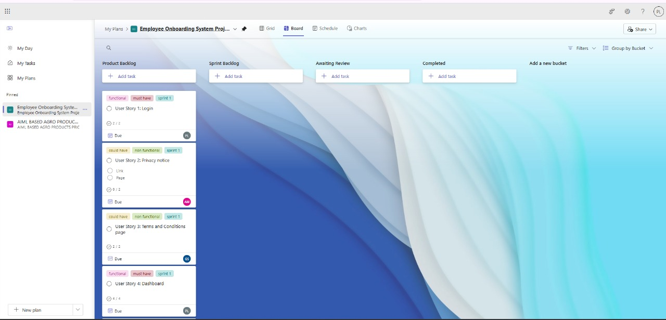

Figure 1.1 MS Planner Board for Employee Onboarding System

**1.7 Product Release Plan**

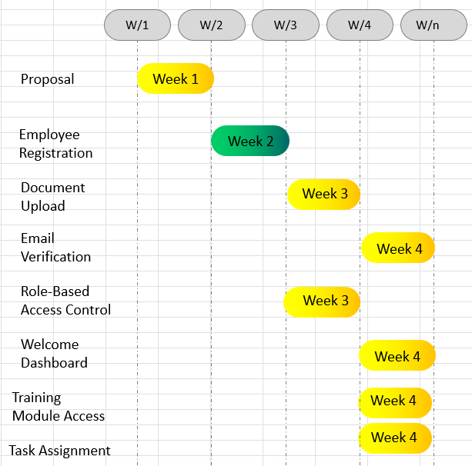

Figure 1.2 Product Release Plan/Roadmap for Employee Onboarding System

**CHAPTER 2**

**SPRINT PLANNING AND EXECUTION**

**2.1 Sprint 1**

**2.1.1 Sprint Goals with User Stories of Sprint 1**

The goal of the first sprint is to develop the foundational front-end components of the Employee Onboarding System and ensure secure, guided access for users. This includes implementing a secure login mechanism, displaying the necessary privacy and policy notices, and offering an intuitive dashboard for employees. Additionally, photo upload functionality is to be integrated to support identity verification. These features form the base for further backend integration and role-based functionality.

The front-end will be developed using HTML, CSS, and JavaScript, with initial server-side routing and responses managed using Supabase.

The following Table 2.1 outlines the detailed user stories for Sprint 1.

**Table 2.1 Sprint 1 User Stories**

|  |  |
| --- | --- |
| **S. No.** | **Detailed User Stories** |
| US1 | As a user, I want a login screen so that I can secure my access. |
| US2 | As an employee, I want a privacy notice so that I can be assured of my privacy. |
| US3 | As an employee, I want a terms and conditions page so that I can gain agreement to terms and conditions. |
| US4 | As an employee, I want a dashboard so that I can have one single view of core functionalities. |
| US5 | As an employee, I want a photo upload provision so that I can upload my pic for identity. |

MS Planner Board description for User Story 1 of Sprint 1 has been shown in Figure 2.1 below:

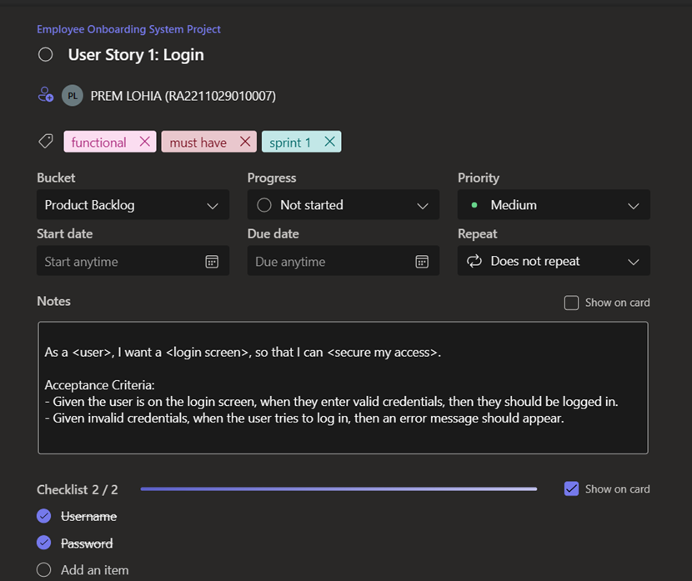

Figure 2.1 MS Planner Board Description for User Story 1

MS Planner Board description for User Story 2 of Sprint 1 has been shown in Figure 2.2 below:

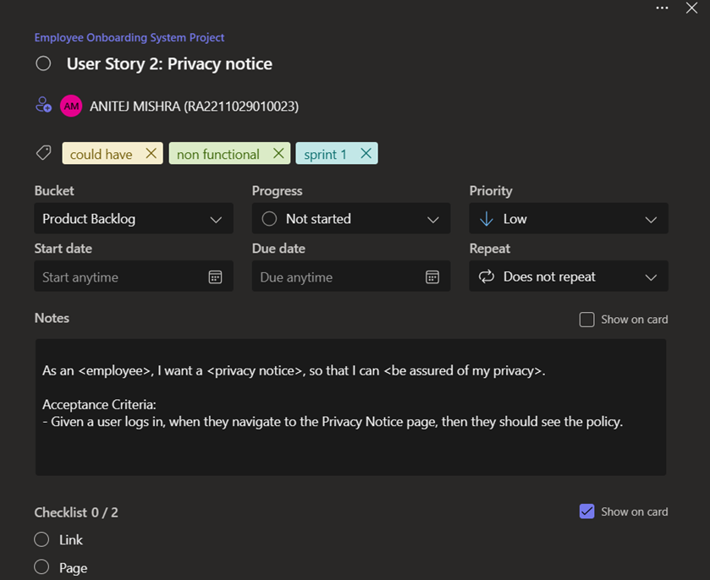

Figure 2.2 MS Planner Board Description for User Story 2

MS Planner Board description for User Story 3 of Sprint 1 has been shown in Figure 2.2 below:

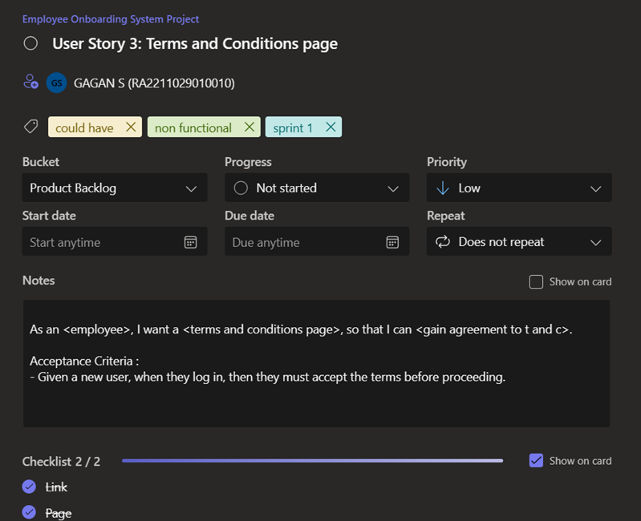

Figure 2.3 MS Planner Board Description for User Story 3

MS Planner Board description for User Story 4 of Sprint 1 has been shown in Figure 2.2 below:

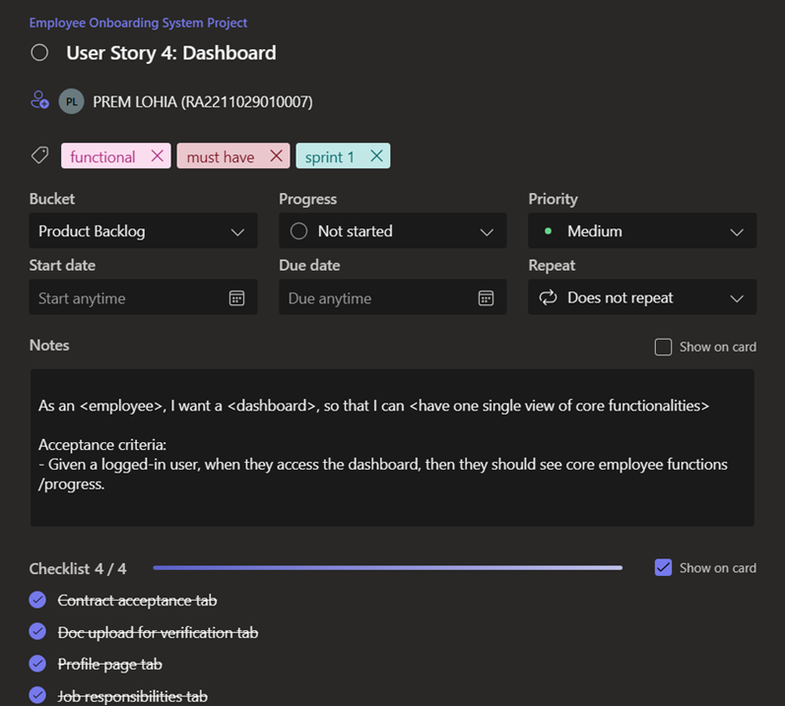

Figure 2.4 MS Planner Board Description for User Story 4

MS Planner Board description for User Story 5 of Sprint 1 has been shown in Figure 2.2 below:

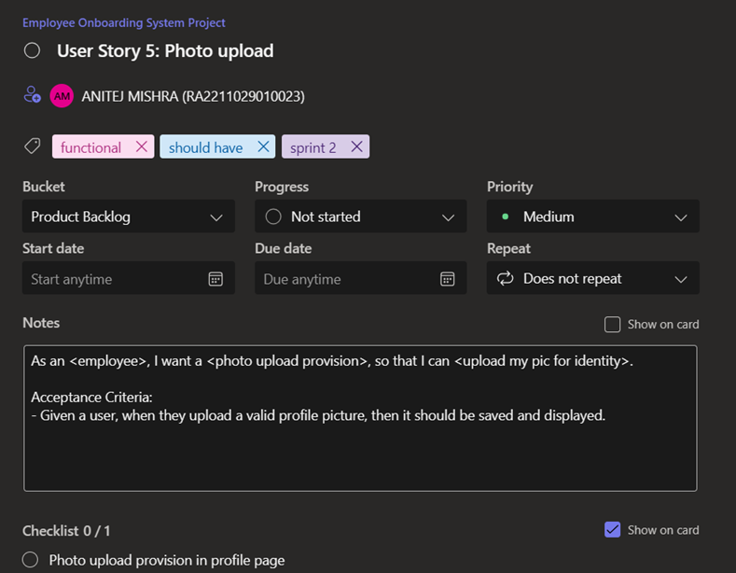

Figure 2.5 MS Planner Board Description for User Story 5

**2.1.2 Functional Document**

**2.1.2.1 Introduction**

The Employee Onboarding Portal is a web-based platform designed to streamline the onboarding process for new hires. It serves as a centralized hub where HR, IT administrators, and new employees can manage essential tasks, documents, and information. Sprint 1 focuses on user authentication, privacy assurance, and a unified dashboard for core functionalities.

**2.1.2.2 Product Goal**

The goal of Sprint 1 is to establish the foundational features of the Employee Onboarding Portal, ensuring:

* Users can securely log in.
* Privacy policies are clearly communicated.
* A dashboard provides a unified view of core onboarding tasks.

**2.1.2.3 Demography (Users, Location)**

**Users**

* **New Hires:** Recently recruited employees going through the onboarding process.
* **HR Managers:** Manage employee documents, onboarding progress, and seat allocation.
* **IT Administrators:** Handle system access, employee ID generation, and technical configurations.

**Location**

The portal supports employees and administrators across:

* **Headquarters**
* **Regional Offices**
* **Remote Locations (fully accessible online for remote employees)**

**2.1.2.4 Business Processes**

The onboarding portal will support the following business processes:

* **User Authentication Process**
  + Trigger: User attempts to log into the portal.
  + Steps:

1. User enters login credentials.
2. System verifies credentials and grants access to the dashboard.
3. If credentials are invalid, an error message is displayed with a password reset option.
   * Outcome: Secure access to the onboarding portal.

* **Privacy Notice Process** 
  + Trigger: User logs in for the first time.
  + Steps:
    - 1. The privacy notice is displayed.
      2. User reviews and acknowledges the privacy policy.
      3. Access to the portal is granted upon acceptance.
  + Outcome: Users are informed about privacy policies before accessing personal data.
* **Dashboard Access Process** 
  + Trigger: User successfully logs in.
  + Steps:
    - 1. User is directed to a personalized dashboard.
      2. Dashboard displays core functionalities such as document submission, offer letter status, and onboarding progress.
  + Outcome: Users have a single view of their onboarding tasks.

**2.1.2.5 Features**

This sprint will focus on implementing the following key features:

* **Secure User Login**

Description: A secure login system that allows users to access onboarding tasks, documents, and resources safely.

User Story: As a user, I want a login screen so that I can secure my access.

* **Privacy Notice**

Description: A privacy policy notice will be displayed upon login, ensuring users understand data protection measures.

User Story: As a user, I want a privacy notice so that I can be assured of my privacy.

* **Centralized Dashboard**

Description: A dashboard that consolidates core onboarding functionalities into a single interface.

User Story: As a user, I want a dashboard so that I can have one single view of core functionalities.

**2.1.2.6 Authorization Matrix**

**Table 2.2 Authorization Matrix for Sprint 1**

|  |  |
| --- | --- |
| **Role** | **Access Level** |
| New Hire | Access to onboarding tasks and document uploads |
| HR Manager | Full access to Employee Data |
| IT Administrator | Access to System Configuration, Employee ID Generation |
| System Admin | Full System Access |

**2.1.2.7 Assumptions**

* The system will integrate with company HR and IT systems for real-time updates.
* All users will have secure login credentials, and data transfer will comply with GDPR and other privacy regulations.
* New hires are expected to upload documents within a specified timeframe to prevent onboarding delays.
* User feedback will be anonymous unless the user opts otherwise.
* HR will have final authority over seat allocation and document verification.

**2.1.3 UI Design**

Figure 2.6 Login Page

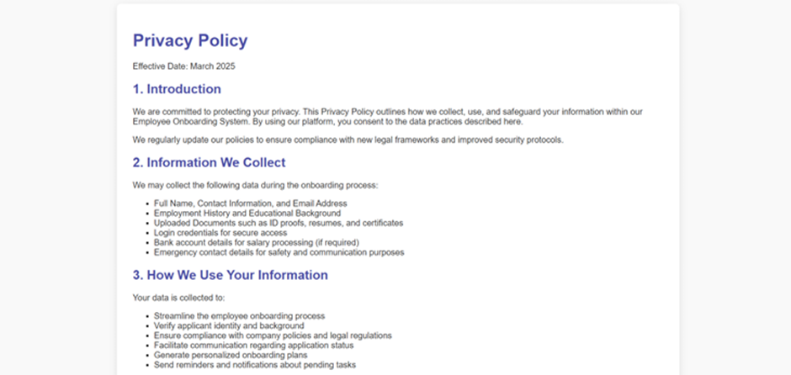

Figure 2.7 Privacy Policy

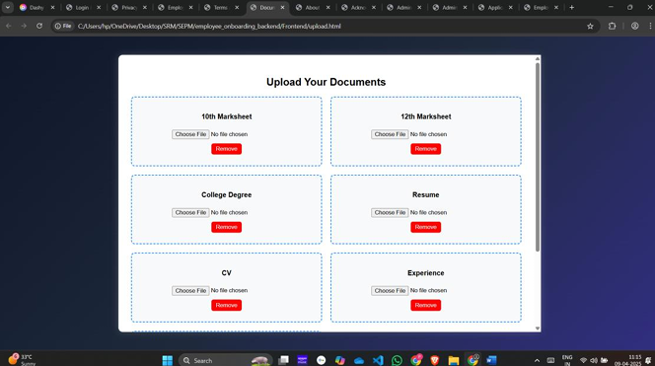

Figure 2.8 Documents Upload

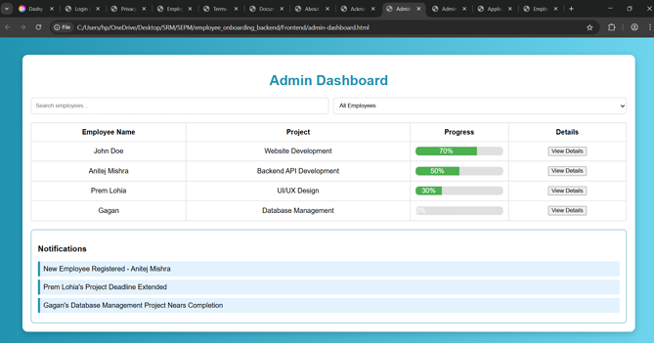

Figure 2.9 Admin Dashboard

**2.1.4 Functional Test Case**

**Table 2.3 Detailed Functional Test Case for Sprint 1**

|  |  |  |  |  |  |  |
| --- | --- | --- | --- | --- | --- | --- |
| **Feature** | **Test Case** | **Steps to Execute Test Case** | **Expected Output** | **Actual Output** | **Status** | **More Info** |
| User Login (Front End) | Valid User Login | 1. Open the application's login page. 2. Enter a valid username. 3. Enter a valid password. 4. Click on the "Login" button. | The user should be given a proper Login Screen with different options like GitHub, Google, etc. | The user is shown a Login Page with different Login Options. | Pass | No error messages are displayed, can be added with unique scenarios in later sprints |
| Agreements and Policies Acceptance | Agreements | 1. Open the application's login page. 2. Click on the given Policies and Agreement link. 3. Read and agree to the Policies and Agreement. 4. Redirect to the Login Page | The system should show the Non Disclosure Agreement, Privacy Policy and Security Policy  The user should be redirected to the Login Page after agreeing to the Policies and Agreement | The system successfully shows the NDA and Policies  The webpages are not yet connected and backend is not developed; redirect function not yet added | Pass (Partially) | The Policies and NDA can be presented in a scrollable document or downloaded as PDF, can be added as a feature in later sprints |
| Dashboard (Front End) | Functional Dashboard | 1. Open the application's login page. 2. Enter a valid username. 3. Enter a valid password. 4. Click on the "Login" button. 5. Redirect to Dashboard Page. | The user should be given a proper Landing Page or Dashboard with Direct Access to multiple different pages like Document Upload, seeing and editing Profile, Documents and Getting Roles Assigned, etc. | The System successfully shows the Dashboard with different tabs for Document Upload, Profile, etc. | Pass | Back End to be developed |
| Document Upload (Front End) | Document Upload and Verification | 1. Open the Applications's Dashboard Page 2. Select the Document Upload Tab 3. Upload valid files 4. Click on the "Upload Files" button | The user should be shown different dropboxes to upload documents with appropriate messages for File Type and Title of the File, with other requirements like File Size | The System successfully shows the Documents Upload page with dropboxes for each required document | Pass | Backend to be developed, to be connected to admin portal for verification |

**2.1.5 Committed VS Completed User Stories**

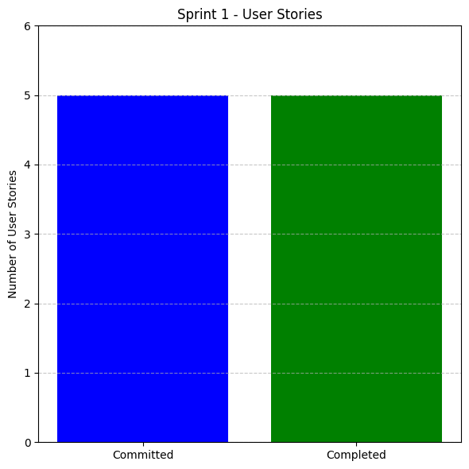

Figure 2.10 Committed VS Completed User Stories for Sprint 1

**2.1.6 Sprint Retrospective**

**Table 2.4 Detailed Sprint Retrospective for Sprint 1**

|  |  |  |  |  |
| --- | --- | --- | --- | --- |
| **What Went Well?** | **What Went Poorly?** | **What Ideas Do You Have?** | **How Should We Take Action?** | **Guidelines** |
| The front ends for various pages have been designed | Initial plan to use Firebase or Supabase was not successful | Plan to use Mongo DB for Back End Development | Set stricter deadlines for finalizing requirements | Finalize technical stack early and freeze UI requirements to avoid rework. |
| The Non-Disclosure Agreement has been designed | Initial plan to create separate Privacy Policy agreement page was not well-received and deferred to next Sprint | Plan to add Privacy and Security Policies in Login Page | Properly set up Back End and create Front End before moving to Back End | Align legal document design with backend workflow to ensure smooth integration. |
| The Privacy and Security Policy has been designed | Back-End was not developed on time and deferred to next Sprint | Plans to edit Terms and Conditions | Refer to existing systems to get a general idea for development insights and current trends along with design language | Keep policies concise and embedded where relevant to improve user accessibility. |
| The Login Page has been designed successfully |  |  |  | Incorporate secure authentication logic early in backend development. |
| The Documents Upload Page has been designed successfully |  |  |  | Define file validation rules and security standards before backend implementation. |
| The Update Page has been designed successfully |  |  |  | Ensure update mechanisms are supported by backend with version tracking and rollback options. |

**2.2 Sprint 2**

**2.2.1 Sprint Goals with User Stories of Sprint 2**

The objective of Sprint 2 is to build and integrate key functionalities for both the front end and back end of the Employee Onboarding System. This sprint focuses on implementing core modules such as employee document verification, admin login, admin dashboard, approval mechanisms, and job descriptions.

The front end is developed using HTML, JavaScript, and CSS to provide a responsive, user-friendly interface. Simultaneously, the back end is being developed to handle document uploads, user authentication, and admin actions. Supabase is used to manage data storage and authentication processes, ensuring secure and seamless communication between both ends.

Login credentials for employees and admins are stored securely, and access is role-specific. Admins can view overall metrics, manage candidate applications, and approve or reject submissions, while employees can upload required documents and review job descriptions relevant to their roles.

**Table 2.5 Sprint 2 User Stories**

|  |  |
| --- | --- |
| **S. No.** | **Detailed User Stories** |
| US 6 | As an employee, I want a doc verification page so that I can upload my core documents. |
| US 7 | As an admin, I want a separate login so that I can secure my access. |
| US 8 | As an admin, I want an admin dashboard so that I can see total employees/applicants, pending reviews, interview schedules and selected. |
| US 9 | As an admin, I want approve/reject buttons so that I can approve or reject employees. |
| US 10 | As an employee, I want a job descriptions page so that I can see the duties related to my role. |

MS Planner Board description for User Story 6 of Sprint 2 has been shown in Figure 2.11 below:

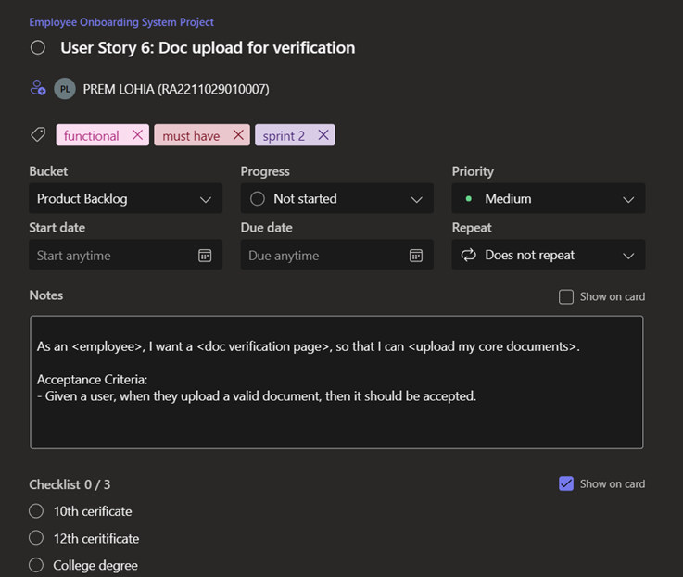

Figure 2.11 MS Planner Board Description for User Story 6

MS Planner Board description for User Story 7 of Sprint 2 has been shown in Figure 2.12 below:

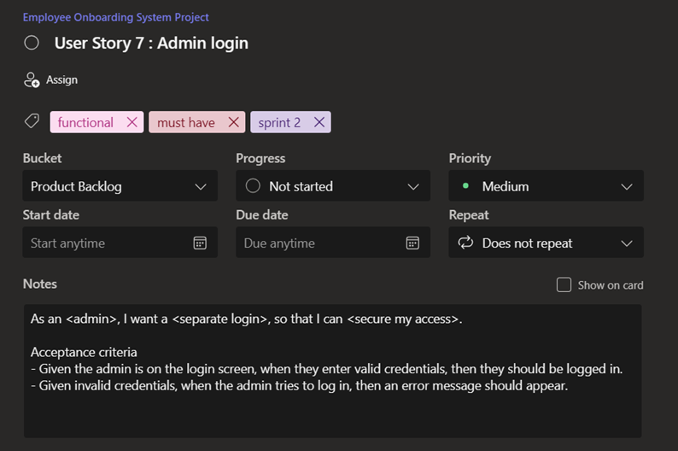

Figure 2.12 MS Planner Board Description for User Story 7

MS Planner Board description for User Story 8 of Sprint 2 has been shown in Figure 2.13 below:

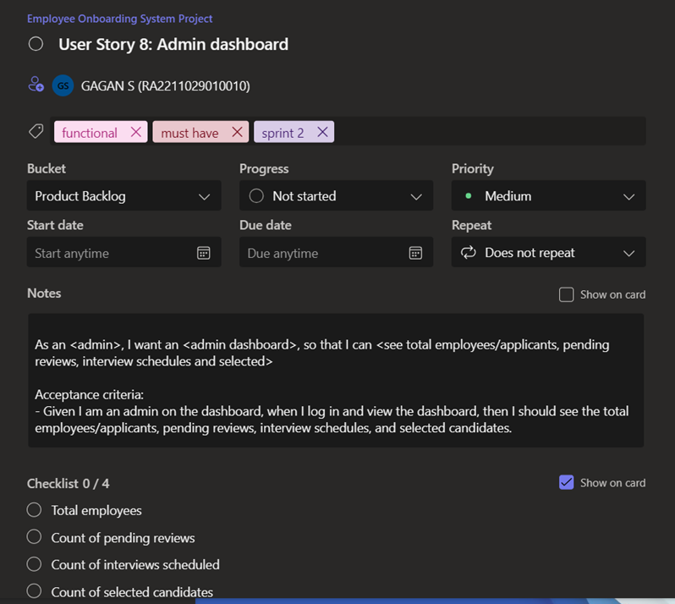

Figure 2.13 MS Planner Board Description for User Story 8

MS Planner Board description for User Story 9 of Sprint 2 has been shown in Figure 2.14 below:

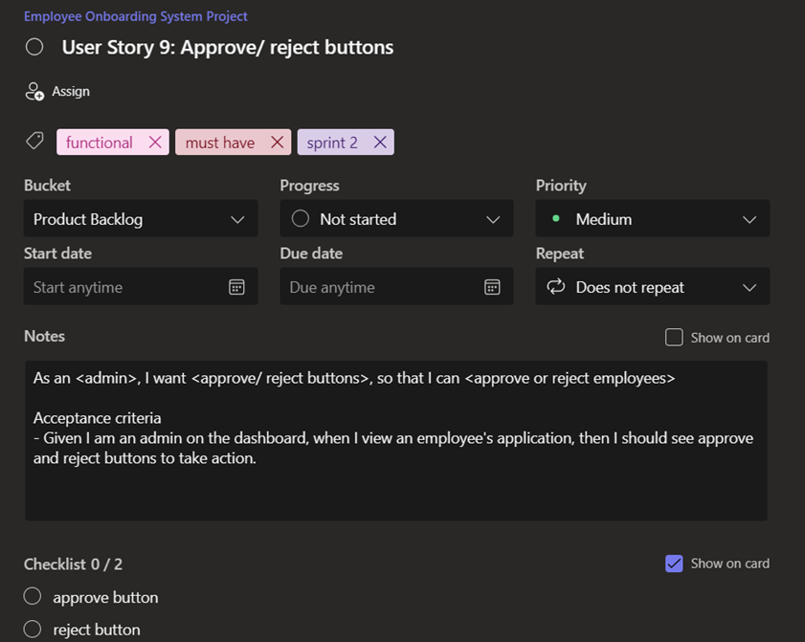

Figure 2.14 MS Planner Board Description for User Story 9

MS Planner Board description for User Story 10 of Sprint 2 has been shown in Figure 2.15 below:

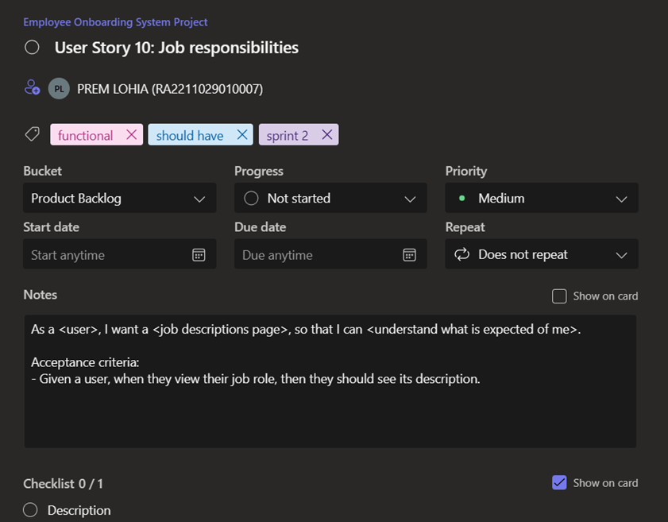

Figure 2.15 MS Planner Board Description for User Story 10

**2.2.2 Functional Document**

**2.2.2.1 Introduction**

The Employee Onboarding Portal continues to evolve in Sprint 2, expanding its capabilities to support administrative functionalities and improve the employee experience. This sprint introduces a dedicated login system and dashboard for admins, along with features that enable admins to manage applicants. Employees also gain access to job-related information through a job descriptions page. Additionally, backend authentication is now managed using Supabase, and legal documentation has been streamlined into a single unified agreement.

**2.2.2.2 Product Goal**

The goal of Sprint 2 is to enhance the onboarding portal with administrative features and improve usability for employees. The objectives include:

* Providing a secure, separate login system for admins
* Creating a dedicated admin dashboard with relevant metrics and actions
* Enabling admins to approve or reject onboarding candidates
* Displaying job descriptions to employees
* Merging the terms and conditions, NDA, and privacy notice into one agreement

**2.2.2.3 Demography (Users, Location)**

**Users**

* New Hires (Employees): Recently recruited individuals going through the onboarding process
* Admins: Oversee onboarding processes, review applications, and manage employee status

**Location**

The portal supports employees and administrators across:

* **Headquarters**
* **Regional Offices**
* **Remote Locations (fully accessible online for remote employees)**

**2.2.2.4 Business Processes**

* **User Authentication Process**
  + Trigger: User attempts to log into the portal
  + Steps:

1. User enters login credentials (authenticated via Supabase)
2. System verifies credentials and routes user to their assigned dashboard (admin or employee)
3. If credentials are invalid, an error message is shown with an option to reset the password
   * Outcome: Secure, role-based access to the portal

* **Legal Agreement Process**
  + Trigger: User logs in for the first time
  + Steps:

1. A unified agreement (terms and conditions, NDA, and privacy notice) is presented
2. User reviews and accepts the agreement
3. Access to the portal is granted upon acceptance
   * Outcome: Legal compliance and informed user consent through a single agreement

* **Dashboard Access Process**
  + Trigger: User successfully logs in
  + Steps:

1. Employees are routed to a personalized dashboard with onboarding tasks
2. Admins are routed to a dashboard showing total employees/applicants, pending reviews, interview schedules, and selected candidates
   * Outcome: Users gain role-specific access to relevant onboarding data

* **Admin Review Process**
  + Trigger: Admin accesses their dashboard
  + Steps:

1. Admin reviews details of applicants
2. Admin clicks "Approve" or "Reject" buttons to make decisions
3. Status updates are saved and reflected system-wide
   * Outcome: Admins manage onboarding progression with clear decision-making capabilities

* **Job Description Access Process**
  + Trigger: Employee navigates to the job descriptions page
  + Steps:

1. Employee selects or views their job role
2. System displays detailed duties and responsibilities
   * Outcome: Employees gain a clear understanding of their role

**2.2.2.5 Features**

**Feature 1: Admin Secure Login**

* Description: A separate login interface for administrators using Supabase for authentication.
* User Story: As an admin, I want a separate login so that I can secure my access.

**Feature 2: Admin Dashboard**

* Description: A dedicated admin dashboard displaying onboarding metrics such as total applicants, pending reviews, interview schedules, and selected candidates.
* User Story: As an admin, I want an admin dashboard so that I can see total employees/applicants, pending reviews, interview schedules, and selected.

**Feature 3: Approve/Reject Functionality**

* Description: Interface buttons on the admin dashboard to approve or reject applicants.
* User Story: As an admin, I want approve/reject buttons so that I can approve or reject employees.

**Feature 4: Job Descriptions Page**

* Description: A portal page where employees can view their assigned job role and responsibilities.
* User Story: As an employee, I want a job descriptions page so that I can see the duties related to my role.

**Feature 5: Unified Legal Agreement**

* Description: Consolidates the terms and conditions, NDA, and privacy notice into a single agreement shown at first login.
* User Story: As a user, I want a single legal agreement so that I can understand and accept all legal conditions efficiently.

**2.2.2.6 Authorization Matrix**

**Table 2.6 Authorization Matrix**

|  |  |
| --- | --- |
| **Role** | **Access Level** |
| Employee | Employee Dashboard, Job Description, Legal Agreement |
| Admin | Admin Dashboard, Approve/Reject Applications, Interview Management |

**2.2.2.7 Assumptions**

* Supabase handles secure authentication for both employees and admins
* Admins have exclusive access to administrative tools and dashboards
* Employees can only view job descriptions and onboarding tasks relevant to them
* Role-based routing determines the correct dashboard experience after login
* The legal agreement is mandatory and must be accepted before any further access is granted
* Admin approval/rejection updates are recorded in real time and reflected immediately
* HR responsibilities such as seat allocation or document verification are handled manually or through admin tools

**2.2.3 Architecture Document**

**2.2.3.1 Application**

We use a traditional Monolithic Architecture.

In our Employee Onboarding Portal, everything - > frontend, backend, and database resides within a single system. There's no separation between the user interface and the business logic. The backend handles everything, from processing user requests to rendering HTML pages and interacting with the database.

**2.2.3.2 Key Components**

1. **Frontend:** The user interface is served by the backend. No API calls are needed. The backend directly renders HTML pages based on user actions like logging in, managing profiles, or uploading documents.
2. **Backend:** The backend processes the business logic (like authentication, document verification) and dynamically generates HTML pages to send back to the frontend. It interacts with the database to retrieve or update data.
3. **Database:** All user data, documents, profiles, and legal agreements are stored in a single database. The backend communicates directly with the database to manage and update data.

**2.2.3.3 Working**

1. User Login: The user submits login credentials via a form. The backend checks the database, and if the credentials are correct, the user is logged in and directed to their dashboard. If incorrect, an error message is shown.
2. Profile Management: When the user accesses their profile, the backend fetches their details from the database and generates a profile page with the user's information.
3. Document Upload: Users upload documents, which the backend stores in the system and updates the document status in the database.
4. Legal Agreements: The backend displays terms & conditions or NDAs, and once the user agrees, their consent is recorded in the database.

**2.2.3.4 Deployment**

The frontend, backend, and database are all part of one unified application. The backend manages all business logic and serves HTML pages directly to the frontend, without the need for external APIs.

Advantages

* **Simplicity:** Everything is bundled into one system, making it easier to develop and deploy.
* **Direct Interaction:** The frontend and backend are tightly integrated, so no APIs are needed for communication.

**2.2.3.5 E-R diagram**

Figure 2.16 E-R Diagram

**2.2.3.6 Data Exchange Contracts**

In our Employee Onboarding Portal, data exchange is handled internally since it's a monolithic system.

1. **Server-Side Rendering:** The backend processes requests and sends back fully-rendered HTML pages with dynamic data, like user profiles or dashboard info. The data is fetched from the database and displayed in the browser.
2. **Form Submissions:** When users submit forms (e.g., login, profile updates), the data is sent to the backend through HTTP requests (POST for submission, GET for retrieval). The backend then processes the data and updates the page.
3. **Session Management**: After login, the backend creates a session and stores a session token in the user's browser. This token is sent with each request to identify the user and keep their data (like profile and document status) consistent.

**2.2.4 UI Design**

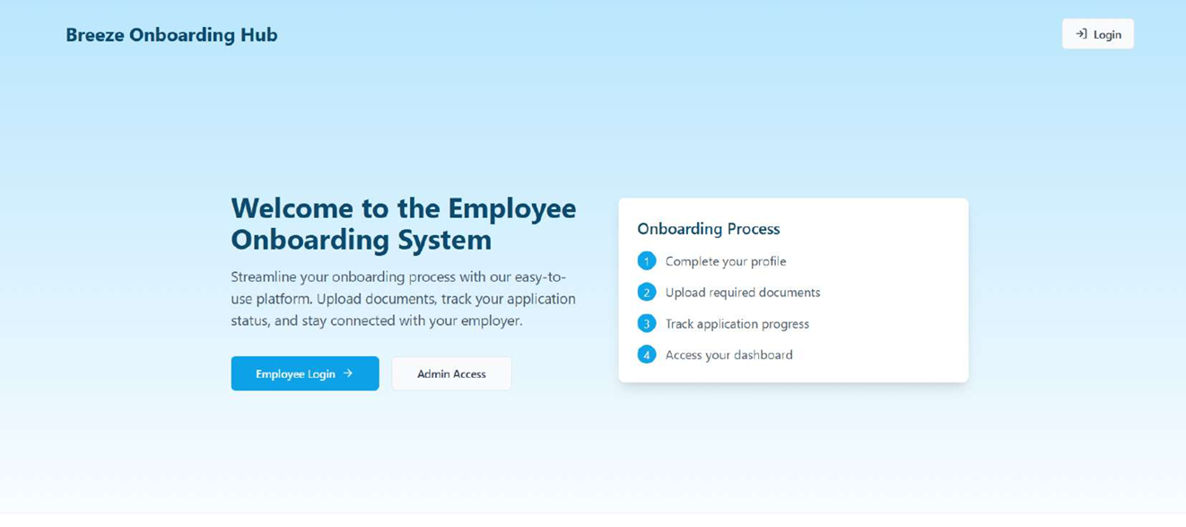

Figure 2.17 Login Page

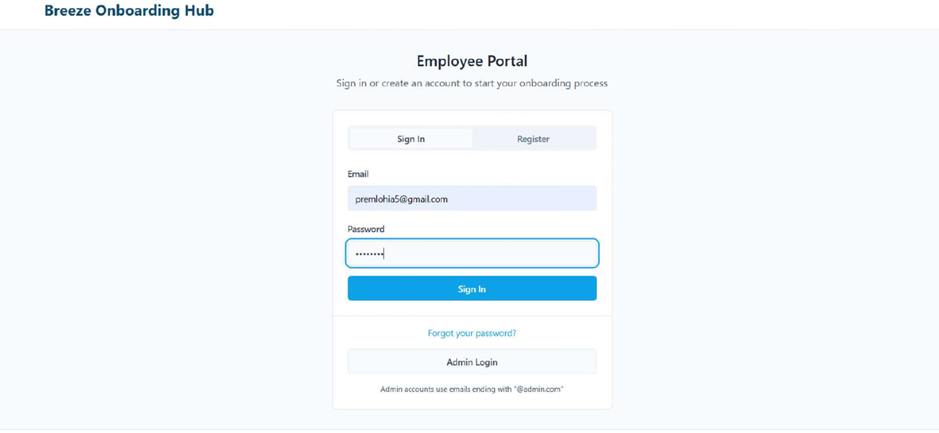

Figure 2.18 Employee Sign In Page

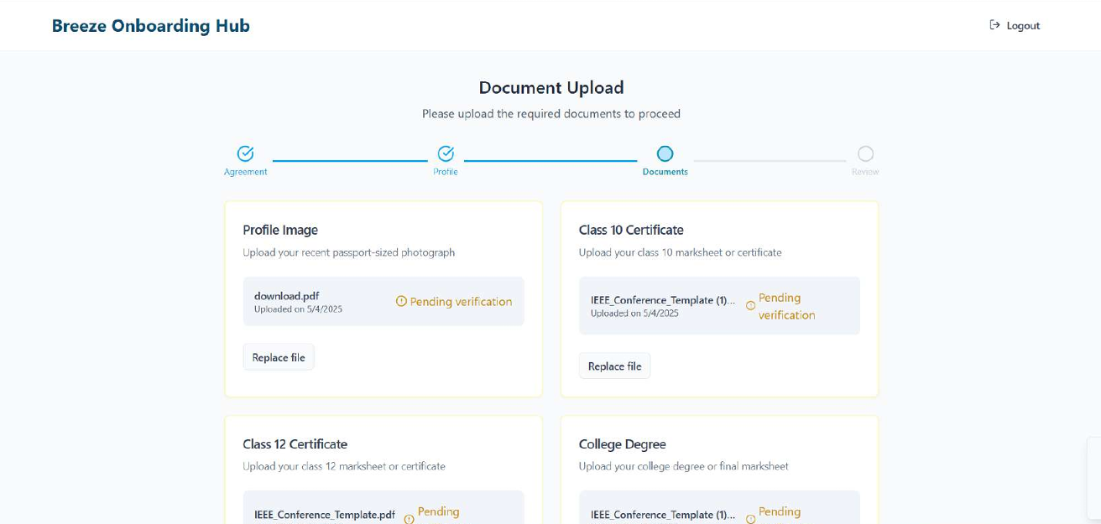

Figure 2.19 Document Upload Page

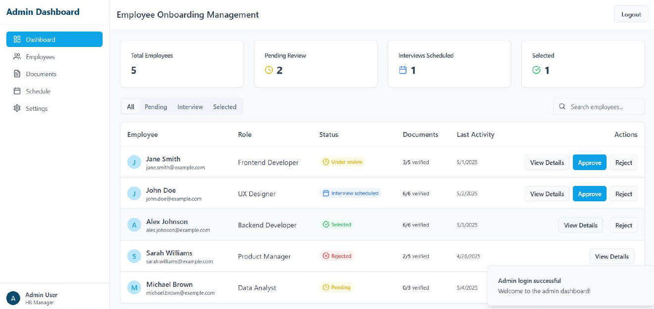

Figure 2.20 Admin Dashboard

**2.2.5 Functional Test Case**

**Table 2.7 Detailed Functional Test Case for Sprint 2**

|  |  |  |  |  |  |  |
| --- | --- | --- | --- | --- | --- | --- |
| **Feature** | **Test Case** | **Steps to execute test case** | **Expected Output** | **Actual Output** | **Status** | **More Information** |
| Admin Login | Valid Admin Login | Open the login page. Enter admin credentials. Click login. | Admin is routed to admin dashboard upon successful authentication. | The user is shown a Login Page with different Login Options. | Pass | Error messages can be useful. |
| Admin Dashboard | Dashboard Load | Log in as admin. Observe the dashboard contents. | Admin sees total applicants, pending reviews, interviews, and selected candidates. | Admin sees total applicants, pending reviews, interviews, and selected candidates. | Pass | This is exclusively for admins only |
| Approve/Reject Applicants | Approve an Applicant | Log in as admin. Navigate to applicants. Click "Approve" on a candidate. | Status of candidate changes to approved and reflects across the system. | No. of candidates selected is incremented | Pass | NA |
| Approve/Reject Applicants | Reject an Applicant | Log in as admin. Navigate to applicants. Click "Reject" on a candidate. | Status of candidate changes to rejected and reflects across the system. | Applicant entry must be removed | Pass | Edge case: Re-approval of a previously rejected applicant should be tested if allowed. |
| Job Descriptions Page | View Job Description | Log in as employee. Navigate to "Job Descriptions" page. | Job role and responsibilities are shown. | To be tested | Pending | Can exclude if short of time |

**2.2.7 Committed VS Completed User Stories**

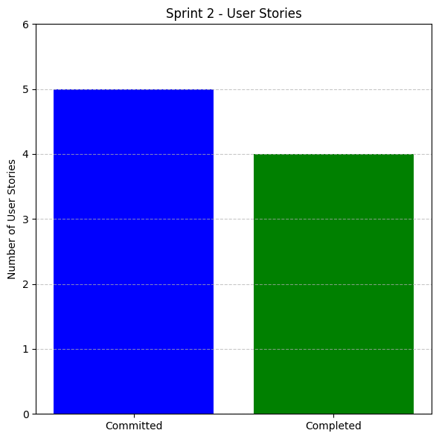

Figure 2.21 Committed VS Completed User Stories for Sprint 2

**2.2.8 Sprint Retrospective**

**Table 2.8 Detailed Sprint Retrospective for Sprint 2**

|  |  |  |  |  |
| --- | --- | --- | --- | --- |
| **What went well** | **What went poorly** | **What ideas do you have** | **How should we take action** | **Guidelines** |
| Admin login with Supabase was implemented smoothly | Initial plan to use Could not implement the Job Descriptions page due to time constraints or Supabase was not successful | Start non-critical features (like Job Descriptions) earlier in the sprint | Allocate buffer time in the sprint for UI implementation and testing | Prioritize by complexity and risk, not just business importance |
| Admin dashboard with approval and metrics was functional and met sprint goal | Late finalization of admin panel UI caused delay in dev |  | Understand working with back-end tools before implementation (instead of learning on the job) | Learning to work with Supabase |
| The Privacy and Security Policy has been designed | A portion of the back-end work which was deferred to sprint 2 couldn't work without errors (storage of uploaded docs in Supabase) |  | Refer to existing systems to get a general idea for development insights and current trends along with design language | Keep policies concise and embedded where relevant to improve user accessibility. |
| Merged legal documents simplified the user experience |  |  |  | Use figma/low-fidelity wireframes early |
| Supabase integration proved reliable and easy to manage |  |  |  |  |

**CHAPTER 3**

**RESULTS AND DISCUSSION**

**3.1 Project Outcomes**

The development of the Employee Onboarding System successfully met the project's objectives of creating a secure, efficient, and user-friendly platform for streamlining onboarding processes. The following key outcomes summarize the project:

* **Fully Functional Onboarding Platform**
  + The application was deployed as a responsive web-based tool to manage employee onboarding from registration to verification.
  + Built using Supabase for backend services and HTML, CSS, JavaScript and Typescript for a clean and intuitive front-end experience.
  + Includes structured user and admin dashboards for managing uploads, approvals, and status tracking.
* **Document Upload and Profile Verification**
  + Users can securely upload essential documents, which are automatically logged and reviewed by administrators.
  + Integrated profile verification system enables accurate and efficient validation of employee data.
  + Status indicators and alerts ensure both parties remain informed throughout the process.
* **Downloadable Reports and Centralized Records**
  + HR personnel can download onboarding reports for recordkeeping.
  + The system maintains a centralized repository for all uploaded documents and onboarding history.
* **Role-Based Access and Real-Time Updates**
  + Distinct functionalities for Admin and User roles enhance clarity and security.
  + Real-time updates reflect changes in profile status, document review, and onboarding progress.
* **User Accessibility and Interface Optimization**
  + Fully responsive design ensures access across desktops, laptops, and mobile devices.
  + User interface is tailored for simplicity, enabling ease of use for non-technical users.
* **Agile Development and Iterative Feedback**
  + Project followed Agile methodology with sprint planning and retrospective sessions.
  + User stories were implemented and refined over multiple sprints, incorporating feedback for improved functionality and usability.
  + Major deliverables were completed by the third sprint, ensuring strong alignment with stakeholder expectations.
* **Scalable Infrastructure for Future Modules**
  + System architecture supports modular additions such as task checklists, onboarding chatbots, and automated welcome kits.
  + Codebase is designed for easy integration with HRMS or third-party APIs.
* **Extensive Testing and Validation**
  + System was tested for performance, data security, and usability using simulated employee data and test accounts.
  + Feedback from HR users and test employees guided final UI improvements and enhanced overall reliability.

**3.2 Summary of Number of Committed VS Completed User Stories**

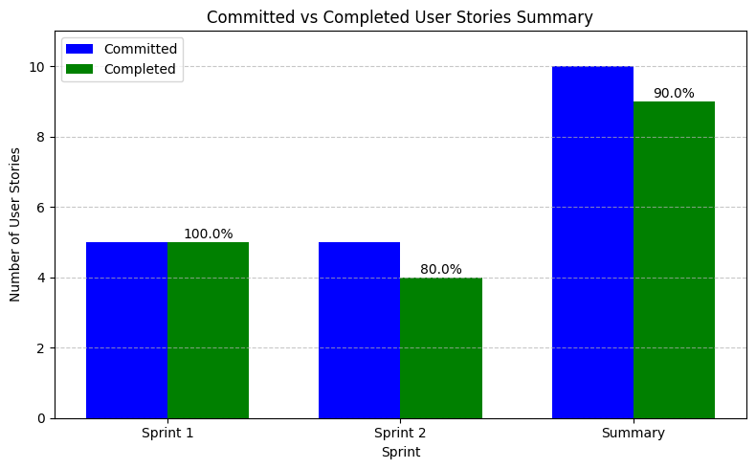

Figure 3.1 Committed VS Completed User Stories Summary

**CHAPTER 4**

**CONCLUSION AND FUTURE ENHANCEMENTS**

The Employee Onboarding System successfully addresses the need for a streamlined, secure, and efficient process for new employee integration within organizations. The platform provides an intuitive interface for both employees and administrators, ensuring that all necessary steps in the onboarding process, from document uploads to profile verification, are easily managed. The system utilizes a secure login mechanism, privacy notice, and terms and conditions acceptance to ensure compliance with data protection regulations.

**Key Features and Outcomes**:

* **Login and Access Control**

The system allows both employees and admins to securely log in to their respective dashboards, ensuring role-based access control.

* **Document Upload and Verification**

Employees can upload their essential documents for verification, streamlining the onboarding process and reducing paperwork.

* **Admin Dashboard**

The admin interface provides a comprehensive overview of all onboarding activities, including employee progress, pending documents, and approvals.

* **User-Friendly Design**

The platform’s design focuses on accessibility, with clear steps for both employees and admins to follow, ensuring a smooth and efficient process.

**Potential Enhancements**

To further enhance the functionality and scalability of the system, the following upgrades are considered for future iterations:

* **Automated Document Validation**

Integrate AI-based tools to automatically validate uploaded documents, further reducing manual effort.

* **E-signature Integration**

Enable digital signing of documents for a more seamless and paperless process.

* **Mobile Application Support**

Develop mobile versions of the system to ensure accessibility for employees who may not have constant desktop access.

* **Multilingual Support**

Implement multilingual capabilities to cater to diverse user bases across different regions and languages.

* **Reporting and Analytics**

Incorporate advanced analytics to track onboarding progress, document completion rates, and overall efficiency.

* **Integration with HR Management Systems**

Enhance system integration with other HR tools for a more holistic approach to employee lifecycle management.

In conclusion, the Employee Onboarding System is a significant step toward improving organizational efficiency by digitizing and streamlining the employee onboarding process. Its secure, user-friendly features provide both employees and administrators with a smooth onboarding experience. With further enhancements, the system can become even more efficient, scalable, and adaptable to future HR needs, contributing to improved employee satisfaction and organizational growth.

**APPENDIX**

**SAMPLE CODING**

Figure A.1 Code for Admin Dashboard

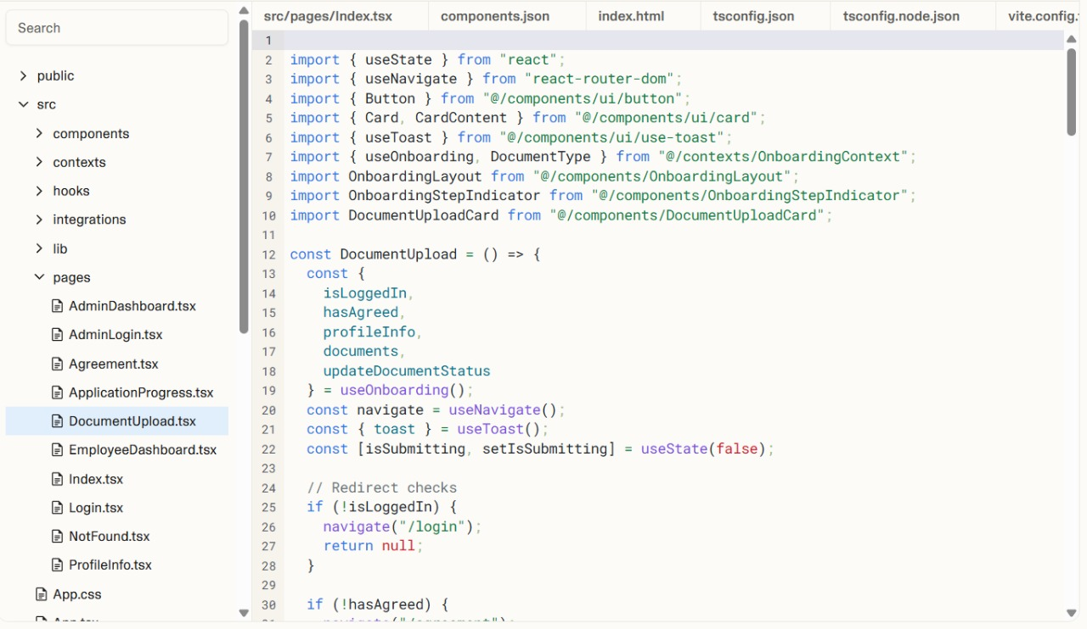

Figure A.2 Code for Document Upload

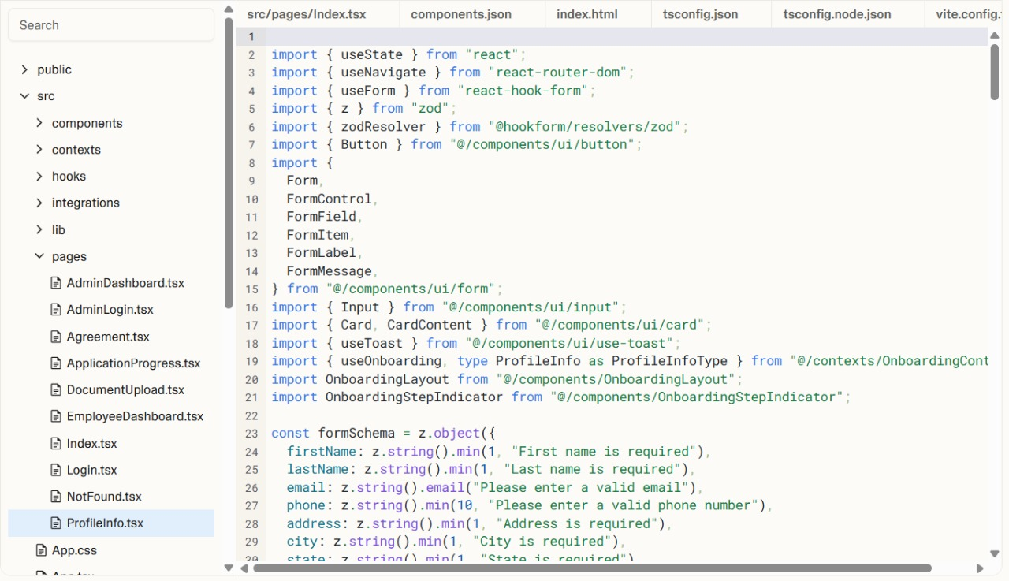

Figure A.3 Code for User Profile

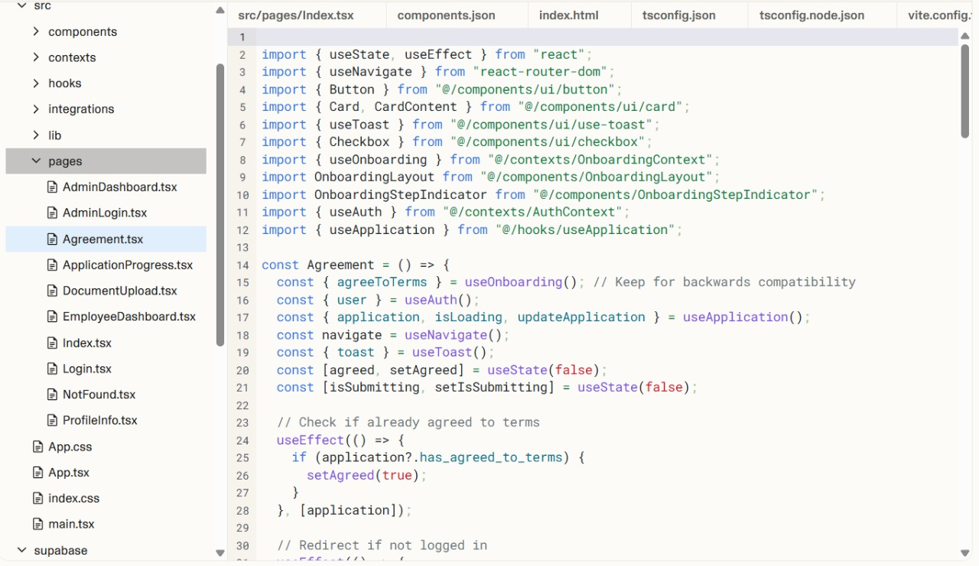

Figure A.4 Code for Agreement Page